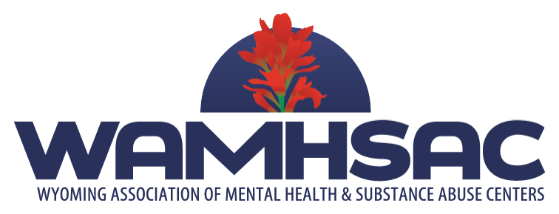

The Wyoming Association of Mental Health and Substance Abuse Centers (WAMHSAC) is made up of 20 centers throughout Wyoming that provide outpatient and/or residential mental health and substance abuse prevention and treatment services. These services are designed to provide the best opportunity for a seamless system of care and to meet the needs of the clients within the communities that these centers serve. All WAMHSAC centers are private, non-profit organizations with volunteer governing Boards.

SUMMARY STATEMENT:

WAMHSAC is currently looking for an exceptional candidate to fill the opening of Executive Director.

The Executive Director will achieve the organization’s mission through implementation of the strategic objectives determined by the organization’s Board of Directors (the Board). The Executive Director will lead the organization toward advancing its mission by creating new possibilities for project initiatives and grants, fostering innovation, leveraging resources, and establishing partnerships. The ideal candidate will be able to successfully manage his/her own schedule and report on deliverables as outlined by the Board of Directors.

This is a self-directed, salaried position.
Travel budget included.
Vacation and healthcare stipend available.

REPORTING:

The Executive Director reports to the Board of Directors and Executive Committee.

ESSENTIAL DUTIES & RESPONSIBILITIES:

  - Formulate goals based on strategic direction of the organization; implements, monitors, and evaluates progress toward established goals; develops plans for expansion or modification of programs and services, in conjunction with Board and Executive Committee.
  - Represents the association on public policy matters, in concert with the Board of Directors and members. Will analyze and make recommendations on public policy to the membership.
  - Stay abreast of current literature in order to advance our understanding of client needs and to continually find more effective ways to serve all who need our services.
  - Work with association directors to broaden training opportunities and learning related to boards, business model and service delivery.
  - Knowledge of best practices and funding opportunities and communicate to association members.
  - Collaborates and communicates with WAMHSAC members, Wyoming Department of Health and Wyoming State legislators to develop positive relationships.
  - Establish and maintain effective working relationships with stakeholders that allow new business opportunities.
  - Provide monthly written reports on key issues, networks that have been engaged and status of specific initiatives.
  - Manage WAMHSAC website.
  - Serve as public spokesperson.
  - Manage budget and ensure positive financial health for the association.
  - Develop and maintain the association’s corporate image and identity, which includes the use of logos and signage.
  - Perform other duties as assigned

POSITION SPECIFICATION

QUALIFICATIONS: Minimum Bachelor’s degree or equivalent experience with professional or trade associations. Advanced degree preferred. Demonstrated effectiveness in strategic planning, healthcare administration and nonprofit advocacy and a track record of operating within the political process. A strong passion and advocacy for behavioral health. Excellent written and verbal communication skills. A team player who can build positive relationships and partnerships.

LOCATION: The selected candidate will be expected to reside in the state of Wyoming, with the preferable location being Casper or Cheyenne.

APPLICATION PROCESS:
If you feel that you are the ideal candidate to step into this exciting role, please electronically submit your cover letter and resume to briana.sheeley@peakwellnesscenter.org by no later than April 12, 2019. The credentials of qualified candidates will be forwarded to the WAMHSAC Search Committee for consideration. Interviews will be conducted by the Search Committee and the hiring decision lies solely with the Board of Directors.

